CTT Scottish District Team Time Trial 2023
GTR Return to Life p/b Streamline are delighted to welcome you to the CTT Scottish Team Time Trial Championships for 2022.

The 31.5-mile course utilises the Irvine by-pass (A78) making in conducive to fast racing and consists of almost 2 full loops of an extended Eglinton course. The unknown quantity will be the wind direction on the day with a light northerly wind favourable to quick times.

Course records –

Men | 54:01 | Ribble Weldtite Pro Cycing | 20/06/2021
Women | 1:05:14 | CAMS Racing | 20/06/2021

Members of the Ayrshire cycling community have come together to help put on this event and we would like to thank them all for their continued support.

We wish you all the very best for your race.

GTR

Race HQ

Eglinton Country Park, Irvine KA12 8TA

Organiser – Stephen Blom 07423666960

Travel Advice

For those competitors who are travelling to Ayrshire from farther afield, below are some pointers for help getting to the area.

From the South

Heading north on the M74, at J4 follow signs for M74 (Glasgow Airport M8).
Follow signage for M77, Kilmarnock.
Exit the A77 at the Bellfield Interchange. Signposted for Irvine, A71.
Proceed on the A71 until the Warrix Interchange (approx 7 miles).
Turn right at the roundabout, follow signs for Ardrossan A78. You are now joining the 10 course. Proceed North on the A78, follow signs for Eglinton Country Park.

From the North

Cross the Clyde via the Erskine Bridge
Exit at Glasgow Airport, following signs for the A737 Stay on the A737 all the way to Kilwinning In Kilwinning, follow signs for Irvine.
Eglinton Park is signposted as ‘Country Park’ just as you leave the town.

From the East/North East

Join the M77 from the M8.
Instructions as above for travel from the South.

Eglinton Park Layout

Parking is indicated in Yellow. Race HQ is outlined in Red. Green is the Shower Block. Both male and female showers are available.

No parking outside the “bus shelter” on the left-hand side next to HQ.

Eglinton Park Staff have asked that riders do not park vehicles on the grass alongside the road throughout the park. Please use the main and overflow car parks which are a few meters further along on the right. Between these three areas there's plenty of parking for everyone.
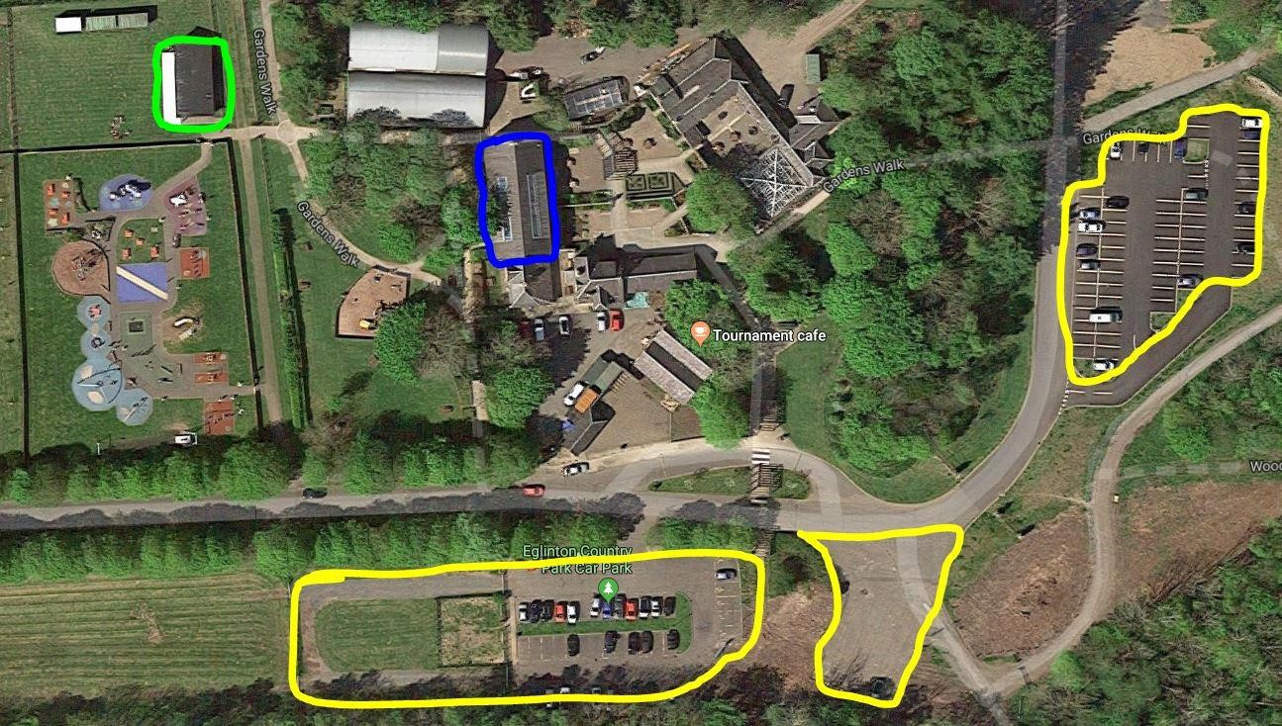

Green is the Start Line. Red is the Finish line

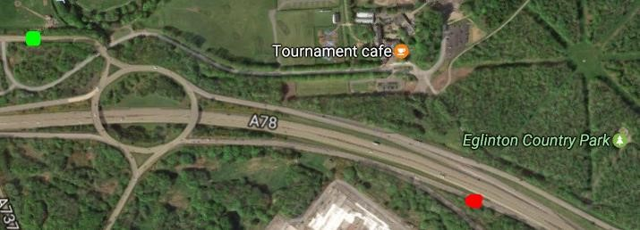

The Course

Start at lamppost No.R5 opposite entrance to Eglinton Country Park. Proceed onto the Eglinton Interchange roundabout and take the 1st exit towards the A78. Stay right on the slip road onto the A78.
Follow A78 southbound, under two interchanges and straight through the Meadowhead roundabout (Dundonald Camp) at the papermill to continue south on A78. Take the next exit slip road to Corraith Rd roundabout. Turn right at roundabout to go under A78 then turn left onto B746 then left again signed A78 Irvine Greenock back onto the A78. Proceed north on A78 around the Meadowhead roundabout and under two interchanges before taking northbound exit slip road to Eglinton Interchange. Carry out turn around interchange and retrace south to Corraith then north along A78 to finishing at the northbound lay-by approximately 500m before the exit slip road to Eglington Interchange. Approx 31.5 miles

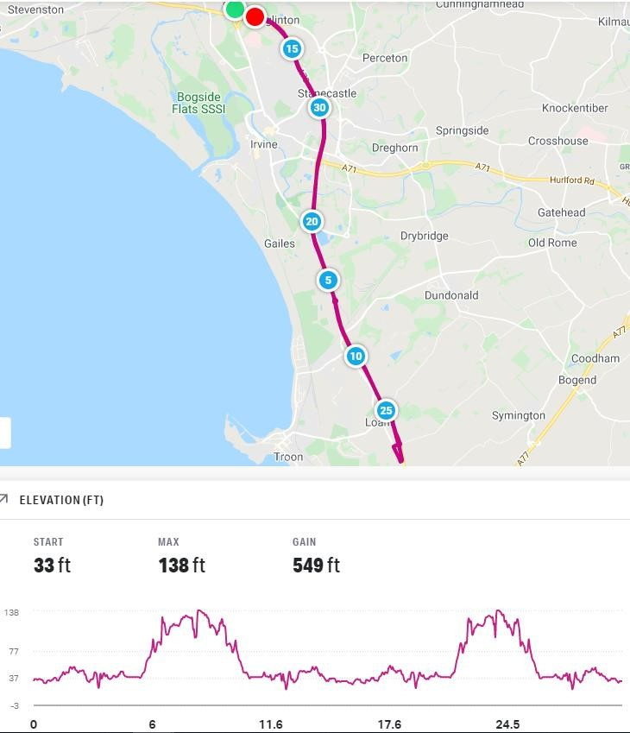

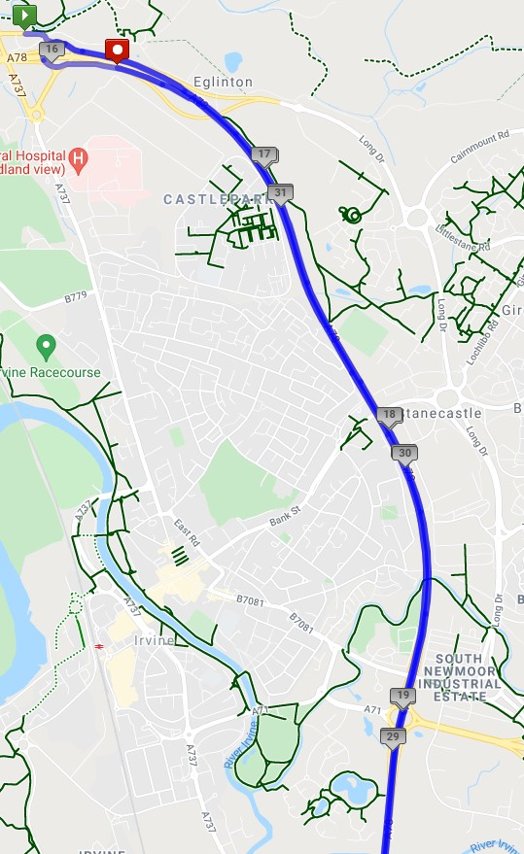

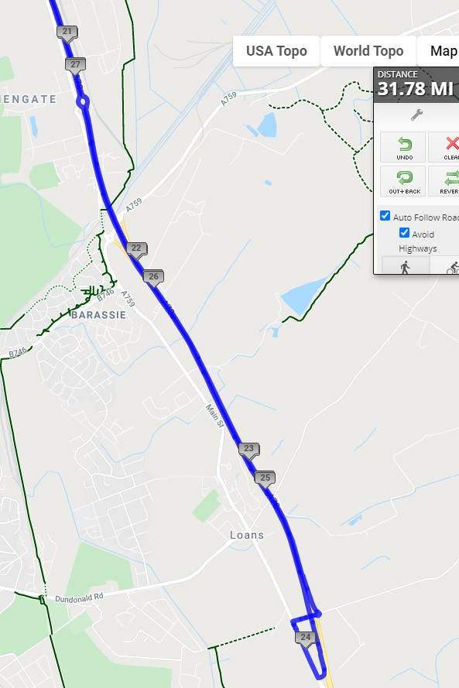

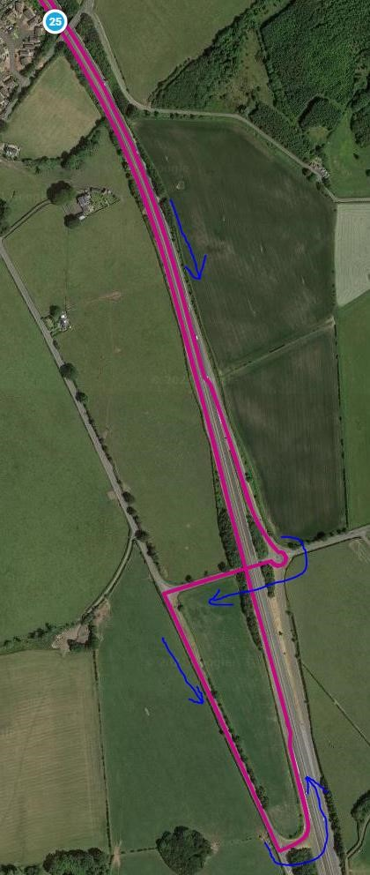

Guidance

At approximately mile 3, riders must move safely to the middle lane of the A78. The inside lane becomes a slip road exit and is not part of the route. Check over your shoulder in plenty of time and move out only when the lane is clear. Marshals will be present to indicate the lane change. Marshals cannot direct or stop traffic – normal rules of the road apply, and you are responsible for your own safety.

At the finish, please proceed up the slip road to the Eglinton Interchange roundabout without delay. Please be aware of traffic joining from the left and proceed with caution after your effort. Also be aware of any team completing lap one and remain clear for them to proceed around the roundabout.

It is recommended that all riders familiarise themselves with the course prior to the race.

Safety Notices

Please make sure your bike is in good condition and ready to be ridden at speed. Do not ride with your head down and make sure you have working front and rear lights on your bike.

Race numbers should be pinned to your lower back visible to the officials.

Marshals will be taking note of any poor riding.

Sign On

Sign on opens at 08.00.

The venue will be getting setup from 8am so please don’t try to sign on before the allocated time. You will be turned away until the team are operational.

Sign-On, Time keepers and the Marshal team are members of the host club, friends and complimented by the wider cycling community.

*** Remember Strava doesn’t know best, and we have fully qualified officials to give you your correct race time****

Prizes

TBC

